**Operating System**

|  |  |
| --- | --- |
| **PRELIM LAB EXAM** | **CS414**  Operating System  **Lesson**  Operating System Structure and Computer System Structure |

Name of student/s: 1. Angelo Adame_____Section: BSCS 4___  Date: Submitted: 06/11/2023

**Directions:** Complete the given image or diagram below. Describe or explain the given image in your own words.

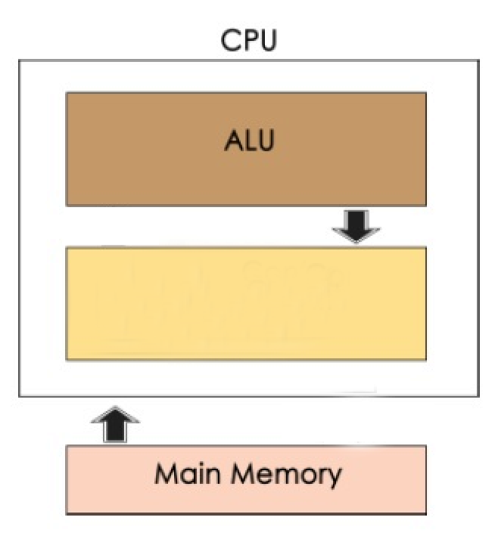

Control Unit

**Criteria:**

1. Content (Completed, provided substantial information and the thought is well-organized)75%

2. Timeliness (The assignment is presented on time)25%

Answer:

The control unit and the arithmetic logic unit (ALU) are the two main components of the focus CPU. After storing information, the ALU analyzes it using comparisons, decision-making and processing. The Control Unit allows data to flow between the ALU and memory, manages the flow of information within the computer chip, and monitors and regulates every framework function. The Main memory stores information and instructions in bytes. When these components work together, the computer chip can handle and process information more effectively, increasing the PC's convenience.

**Operating System**

|  |  |
| --- | --- |
| **PRELIM LAB EXAM** | **CS414**  Operating System  **Lesson**  Operating System Structure and Computer System Structure |

Name of student/s: 1. Angelo Adame__________Section:BSCS 4____  Date: Submitted: 06/11/2023

**Directions:** Complete the given image or diagram below. Describe or explain the given image in your own words.

**Time-Sharing Operating Systems**

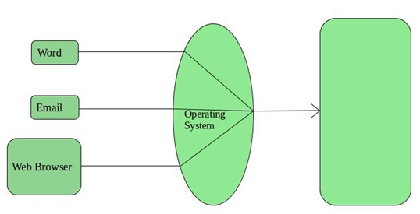

CPU

Answer:

In this image, we can see the word, email, and web browser. It passes to OS where they pass as one, and after going to Cpu each program is given a certain amount of CPU time while multitasking systems are in operation, preventing any one user from controlling the system's resources and encouraging equitable CPU utilization. It ensures the system functions efficiently, enabling multitasking and meeting the demands of diverse users.

Submit your doc file with the following filename:

**YOURSECTION_FAMILYNAME_FIRSTNAME _PRELIMLABEXAM**